|  |
| --- |
| **Disclaimer**  This is a **template** for the Software Requirements Specification (SRS) that students may use. It povides a **starting point** for the preparation of SRS.  **Note to authors**  If you add any new sections to the document please make sure that you maintain the header and text styles.  Before submission of the first draft of this document please make sure to update the Table of Contents and to delete this page.  **Author**: Dr. C. Constantinides <cc@cse.concordia.ca> |

**Table of contents**

Purpose 5

Scope 5

Definitions, acronyms, and abbreviations 5

References 5

2. Overall description 6

Product perspective 6

Product functions 6

User characteristics 6

Constraints 6

Assumptions and dependencies 6

3. Specific requirements 7

External interfaces 7

Functionality 7

Actor goal list 7

Use case view 8

Reliability 8

Usability 8

Efficiency 8

Maintainability 9

Portability 9

Design constraints 9

(On-line) user documentation and help 9

Purchased components 9

Licensing requirements 9

Legal, copyright and other notices 9

3. Analysis Models 1010

## Actor goal list

|  |  |
| --- | --- |
| Actor | Goal |
| User/Student | -Access system  -View directory of rooms  -Make a reservation  -Cancel a reservation  -Modify a reservation  -View list of reservations in the registry (view availability of rooms) |

Figure 1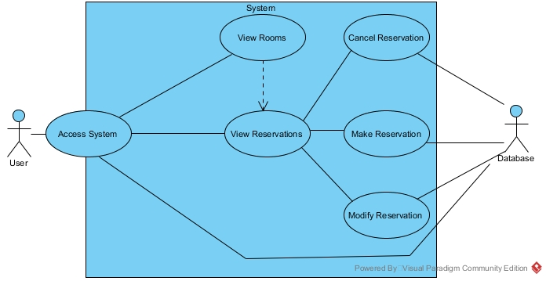

Figure 1. Use case model.

## Reliability

-The mean time between failures shall exceed 1 month.

*Note: In testing the system, we can shorten or prolong this amount of time, since it is currently difficult to determine*

## Usability

-The reservation system must be available to use from any commonly used web browser application (and relatively recent version).

*Commonly used web browsers: Google Chrome, Firefox, Internet Explorer, Opera, Safari, Microsoft Edge.*

-The reservation system shall be accessible to any type of student, regardless of department.

-Users will only be allowed to make a reservation in another room after already making one, once every 5 minutes.

-Users will only be allowed to add themselves to a single waiting list once every 2 minutes.

-Users cannot exist in a single waiting list more than once.

-Users cannot maintain more than 3 reservations for a single week period.

-Users may hold a position in any number of waiting lists for reservations, so long as they have not already reached the maximum number of reservations for the week (currently 3).

-Users holding the top position in a waiting list queue will be given the reservation for that room and timeslot if the current holder cancels their reservation.

-Users given a reservation for a room will be removed from all other waiting lists if they have reached the maximum allotted reservations for the week.

*Note: Timeframe and numbers are subject to change upon negotiations*